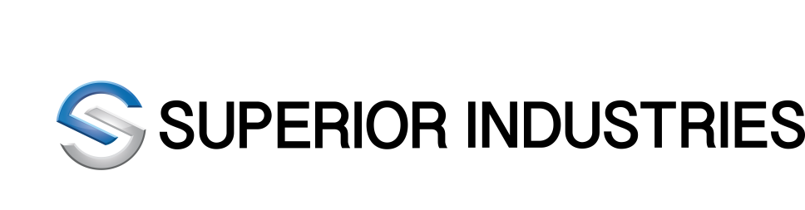
News Release

Superior Industries Declares Quarterly Cash Dividend

SOUTHFIELD, MICHIGAN – March 4, 2019 – Superior Industries International, Inc. (NYSE:SUP), today announced that its Board of Directors has declared a quarterly cash dividend of $0.09 per share, payable on April 18, 2019, to shareholders of record as of April 4, 2019.

About Superior Industries

Superior is one of the world’s leading aluminum wheel suppliers. Superior’s team collaborates and partners with customers to design, engineer and manufacture a wide variety of innovative and high quality products utilizing the latest lightweighting and finishing technologies. Superior also maintains leading aftermarket brands including ATS®, RIAL®, ALUTEC®, and ANZIO®. Headquartered in Southfield, Michigan, Superior is listed on the New York Stock Exchange and is a component of Standard & Poor’s Small Cap 600 and Russell 2000 Indices. For more information, please visit www.supind.com.

Contact:

Superior Industries Investor Relations:
Troy Ford (248) 234-7104
Investor.Relations@supind.com

